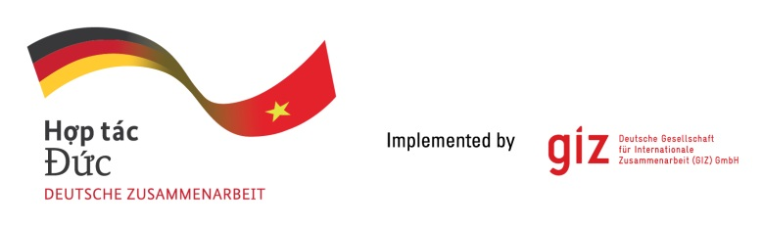

**Consultancy service for Study**

***“Assess (Support) long-term energy planning with a focus on the power sector contribution (including e-mobility) to reach socio-economic and environmental goals”***

As a federal enterprise, the Deutsche Gesellschaft für Internationale Zusammenarbeit (GIZ) GmbH supports the German Government in achieving its objectives in the field of international cooperation for sustainable development. On behalf of the German Government, GIZ currently provides advisory services to the Government of Viet Nam in three priority areas: (1) Vocational training, (2) Environmental policy and sustainable use of natural resources, and (3) Energy. Please visit [www.giz.de/viet-nam](http://www.giz.de/viet-nam) for further information.

The project “***Clean Affordable and Secure Energy for Southeast Asia (CASE)***” implemented by GIZ is looking for 06 positions of local consultant to conduct a study “*Assess (Support) long-term energy planning with a focus on the power sector contribution (including e-mobility) to reach socio-economic and environmental goals”.*

Therefore, GIZ is looking for **06** qualified local consultant positions **(here after called as LC)** to carry related tasks as below:

1. Timeframe of the assignment: tentatively commence from 31st July 2021 until 31st January 2022.
2. Place of Assignment: Hanoi
3. Estimated man-days and Qualification requirements.

|  |  |  |  |  |
| --- | --- | --- | --- | --- |
| **No** | **Position** | **Tender code** | **Estimated**  **man-days** | **Qualification requirements** |
| 1 | Team leader | LC 01 | 70 | * A relevant Master’s degree plus more than 15 years relevant full-time work experience in the field of energy/energy policy/energy economic or similar. * Proven high capability of conducting scientific research in the related field through the list of scientific publications. * Proven extensive experiences in leading/managing scientific research in collaboration with national and international organization. * Familiarity with think-tank’s project preparation policies and technical reports, and prior work experience on sector reform and/or energy projects in Vietnam and/or Southeast Asia would be an advantage. |
| 2 | Energy/Power Sector Modelling Expert | LC 02 | 60 | * A relevant Master’s degree plus more than 15 years relevant full-time work experience in energy and power system or similar. * Proven extensive knowledge of the political landscape of Vietnam energy/power sector through the experience in leading and participating in related research/publications. * Proven extensive knowledge of global trend of energy/power sector development through the experience in leading and participating in related publications/projects. |
| 3 | Natural Resources Management Expert | LC 03 | 60 | * A relevant Master’s degree plus more than 15 years relevant full-time work experience in environmental/natural resource management, environmental economics and policy or similar. * Proven extensive knowledge of the political landscape of Vietnam in related fields through the experience in leading and participating in related research/publications.   Proven extensive knowledge of international energy/environmental/economic policy through the experience in leading and participating in related publications/projects |
| 4 | Economics Expert | LC 04 | 60 | * A relevant Master’s degree plus more than 15 years relevant full-time work experience in development economics, macroeconomics for similar. * Proven extensive experiences in advising policy and providing high-level policy recommendations. * Proven extensive experience in leading and participating projects at national level on crafting the policies, regulations on economic development as well as project in collaboration with international and nation organizations. |
| 5 | Urban Planning Expert | LC 05 | 60 | * A relevant Master’s degree plus more than 15 years relevant full-time work experience in urban development/planning or similar. * Proven extensive experiences in leading and participating in urban planning and development research/projects. * Familiarity with climate change adaptation and mitigation, green growth, green city… in Vietnam is an advantage. |
| 6 | Transportation Expert | LC 06 | 60 | * A relevant Master’s degree plus more than 15 years relevant full-time work experience in transportation planning, transportation infrastructure development or similar. * Proven extensive knowledge of analysing and assessing transport infrastructure development policy and investment in Vietnam. * Proven extensive experience in leading and participating in transportation planning and development projects/research. |

1. Requirements: 06 local consultants will be contracted to work in a team to conduct the study “*Assess (Support) long-term energy planning with a focus on the power sector contribution (including e-mobility) to reach socio-economic and environmental goals”*.

Apart from aboved mentioned qualification requirements, all experts are expected to possess the following skills.

* Demonstrable ability of analytical and drafting work, etc.
* Excellent analytical, teamwork and facilitation skills.
* Ability to meet deadlines and prioritize multiple tasks.
* Proficiency in both Vietnamese and English language

Interested Local Consultant is requested to submit the following documents with specified tender code to the position (s) that he/she wish to apply to *both**emails*: [**mai.tran@giz.de**](mailto:mai.tran@giz.de)

[**tuan.le@giz.de**](mailto:tuan.le@giz.de)

1. *Cover letter (with signature)*
2. *Curriculum Vitae (CV)*

Deadline for document submission is 21 st June 2021. Bids sending via email or fax after the deadline will be disqualified.

Only the shortlisted bidders will be contacted for official technical and financial offer.